# 3- Read about the new app and answer the questions with your opinions.

A new productivity application called "TaskMaster" has been developed to help users manage their tasks and increase their efficiency. The application allows users to create, organize, and prioritize tasks, set reminders, and track their progress. It also provides data visualization and analytics to help users analyze their productivity patterns.

1. What do you think about the concept of the "TaskMaster" application?
2. Could you suggest any additional features that might enhance the functionality of the application?
3. Can you think of any potential challenges or limitations that users might face while using the application?
4. Can you envision any potential integration possibilities with other applications or platforms that could enhance the overall user experience?
5. 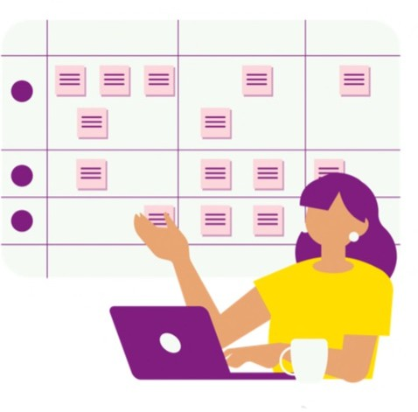Could you provide any suggestions on how the developers could market and promote the "TaskMaster" application

effectively?

# Homework

Now that the app “TaskMaster” is ready, you need to present it in a meeting for the final client. What are you going to say? Imagine that your classmates are the clients and prepare a little oral presentation about the product. Use your imagination to make this app really appealing to the



public.

6

3